Power BI Assignment 1 –Data Transformation & Data Modeling

E-Commerce Sales Analysis

This assignment will help you explore e-commerce sales data analysis using Power BI.
Below are the files you will be working with (click on each to download):

★ List of Orders.csv
★ Order Details.csv
★ Sales target.csv

In this exercise, you will leverage Power BI's capabilities to import, transform, model, and
analyze the provided data.

Instructions:-

Import Data:

● Import “List of Orders.csv” into Power BI.
● Open “List of Orders” in Power Query Editor by clicking on ‘Transform’.
Get Data→Text/CSV→Select “List of Orders.csv” →open→Transform
● Import “Order Details.csv” and “Sales target.csv” into Power Query Editor.
Data Transformation:
Get Data→Text/CSV→Select “Order Details.csv” →open→Transform
Get Data→Text/CSV→Select “Sales target.csv” →open→Transform

● Restrict the "List of Orders" table to only the first 500 rows.
Select list of orders – Keep rows- keep top rows – number of rows – 500 ok

● Ensure the “Order Date” column in the “List of Orders” table is set to data type 'Date'.
Select order date→Right click→change type→Date→change date→but some fields occurs “Error” So
Change type→use locale→Date→English(United Kingdom)→ok

● Change the data type of “Amount” and “Target” columns to ‘Fixed Decimal Number’.
Order details→select amount→change type→ “Fixed Decimal Number”

● Format the "CustomerName" column into proper case, ensuring consistent
capitalization for each word.
Change type→Capitalize for Each Word

● Merge the "State" and "City" columns to create a new column named "Location" in
the format ‘City, State’.
Add new column→Location→Insert = [CITY] & “ “ & [STATE]

● Create a new custom column named "Profit Margin" as the percentage of "Profit"
divided by "Amount".
Add new column→Profit Margin→Profit/Amount→ok→ Change type→Fixed Decimal Number
● Add a new conditional column named "Profit Status" based on the values in the
"Profit" column. The conditions are as follows: if the profit is less than 0, the label
should be "Loss"; if the profit equals 0, the label should be "Break-Even"; and if the
profit is greater than 0, the label should be "Profit".
Add condition column-
New Column name→Profit Status
Column name Operator Value Output
Profit is less than 0 Loss
Profit equals 0 Break-Even
Else
Profit

Merging Data (Joins):
● Merge the "List of Orders" and "Order Details" tables into a new single table named
"Orders Data" based on the "Order ID" relationship.

Home → Merge Queries → Merge Queries as New
First table: List of Orders
Second table: Order Details
Click Order ID column in both tables
Left Outer (All from first, matching from second)
Click OK

Click the expand icon at the top of that column.
Select Product, Quantity, Sales, Profit, etc.
Click OK

Rename Orders Data
Orders Data

Handling Missing Data & Duplicate Data:
● Identify missing values in the data and determine a strategy to address them.
Select Table→View→Check→Column Quality, Column Distribution, Column Profile→All Column is Valid No Error and Null Values

● Check for duplicate rows and define a strategy to handle duplicates.
Home → Keep Rows → Keep Duplicates→empty → so no duplicates

Sorting and Filtering Data:

● In the ‘Orders Data’ table, utilize sorting and filtering techniques on columns like
Order Date, State or Category to analyze data based on specific criteria:
◆ Sort the orders by Order Date in descending order to analyze recent trends.
Select OrderID→Click the Corner→Decening Order

◆ Filter the orders to focus only on a specific state (e.g., Tamil Nadu) for
regional analysis.
Select State→Click the Corner→Filer-Tamilnadu
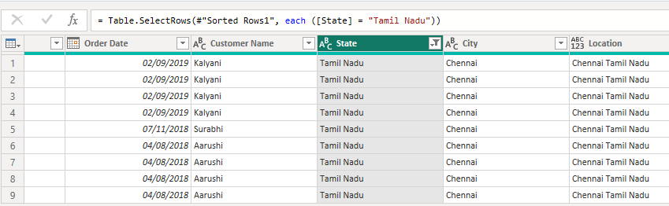
Grouping and Aggregating Data:
● Duplicate the “Order Details” table and calculate the count of each Order ID, average
profit by Category or total amount by Sub-Category.
Calculate the count of each orderID
Select Order Details Summary table.
Go to Home → Group By.
Settings:
Column Operation
Order ID Count Rows Ok
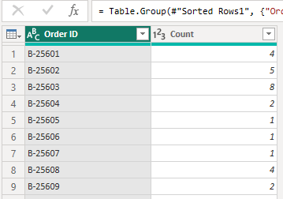

Average Profit by Category
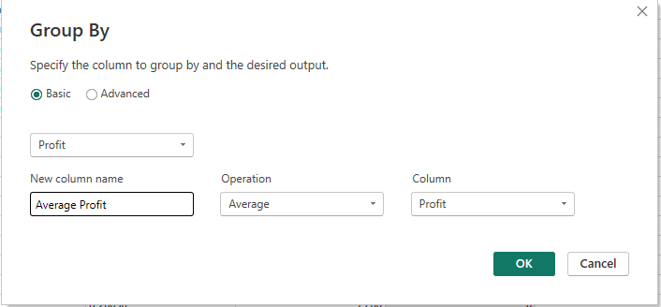
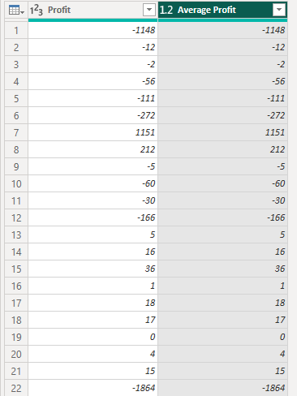

Total Amount by Sub-Category
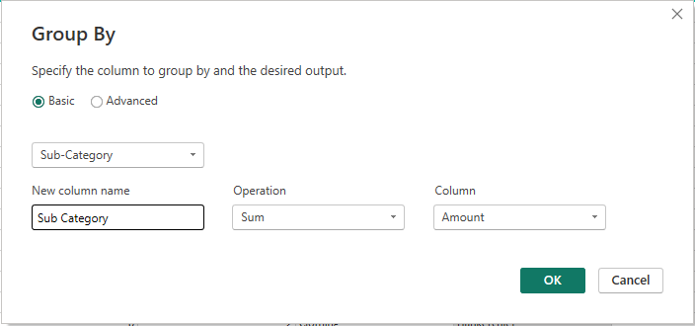
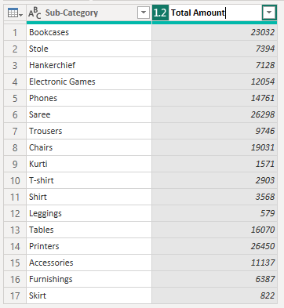

● Duplicate the “Sales Target” table and aggregate the total target amount by Month of
Order Date.

Sales target→Duplicate→Rename the table as Monthly Target Summary.
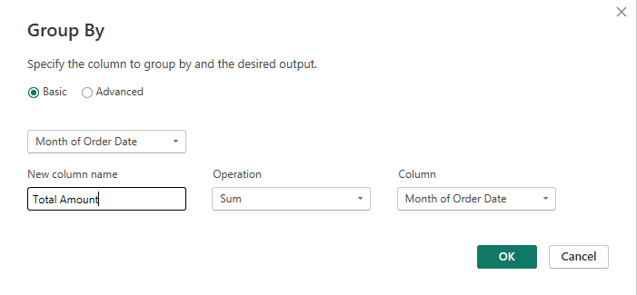

Select month of order date – select sort ascending
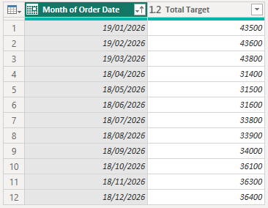

Data Modeling:
● Establish a relationship between the “List of Orders” and “Order Details” tables using
the ‘Order ID’ column.
Import “List of Order” and “Order Details” → Click Model view→

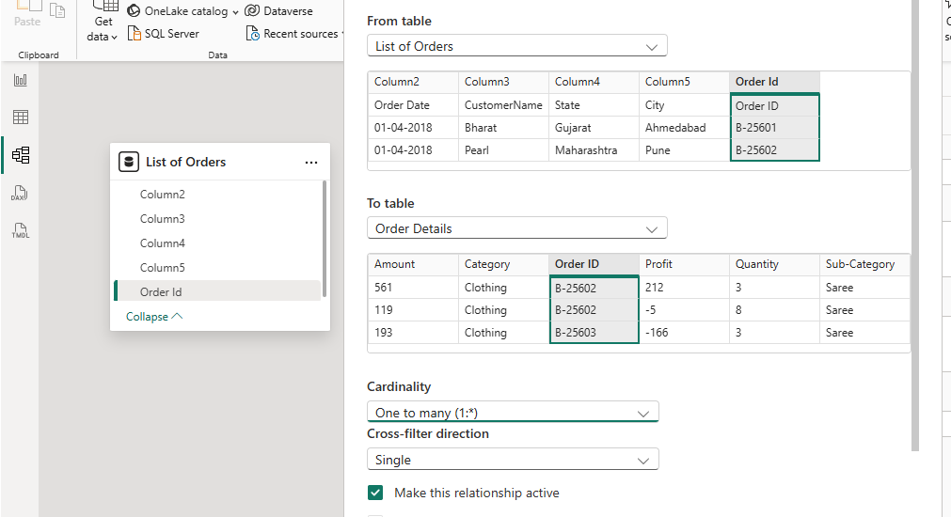
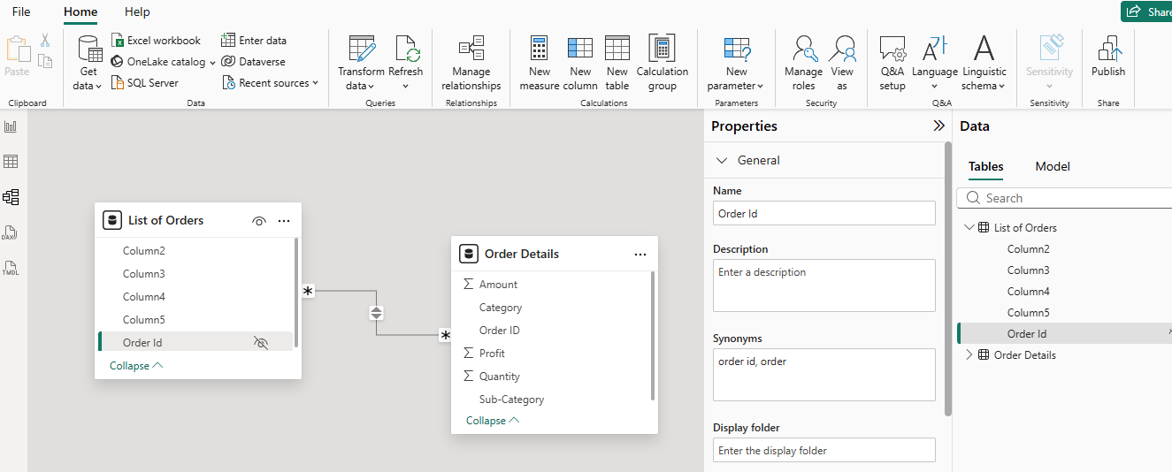

● Build a relationship between the “Order Details” and “Sales Target” tables based on
the ‘Category’ column. Click "Manage relationships" and ensure this relationship is
active.

